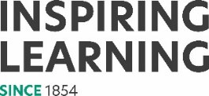
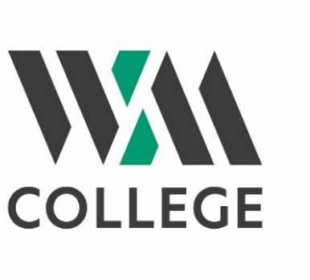

Equality, Diversity and Inclusion Statement

Created by | HR Manager | May 2022
Approved by | FPDC
Version | 1.0
Date of next review |  | May 2024

The vision of WM College is WM College has a vision to be an inclusive, outstanding college.
The mission of WM College is to provide diverse, enriching and enjoyable lifelong learning, including skills for work, in a supportive environment for adults in Camden and the local area.
Our core values are:
- WM College is Learner Centred: We strive to enable all learners to achieve their potential and to enjoy their learning with us. We listen to our learners and are adaptable, flexible, and responsive to learner needs.
- WM College is committed to Continuous Improvement and Excellence: We constantly review what we do and how it could be improved to ensure that we get better.

- WM College is Respectful: We promote equality and celebrate diversity. We respect differences and treat people as individuals. We are understanding of each other’s values, cultures and beliefs and observe these in our interactions with each other.

- WM College is Collaborative: We work together to meet our common goals, valuing each other’s contribution. We share and celebrate the talent, skills, knowledge, and experience of every person at WMC.

The following Equality, Diversity and Inclusion Statement has been developed to enable this commitment to be fulfilled. Implementation will be a step-by-step process which will be monitored annually against the College’s Self-Assessment Report and Improvement Plan. This commitment is underpinned by the Equality Act 2010.
Statement
WM College is committed to valuing diversity, and to promoting and implementing equality of opportunity in all its activities.
This commitment is based on the principle that those who learn, work and are involved in the College should be treated fairly and with respect. The performance of the College depends on all people having a stake in its future and recognising that everyone has both rights and responsibilities within this context.
The College will work towards an environment and culture where everyone is encouraged and supported to develop their full potential; this includes giving due regard to protected characteristics as outlined in the Equality Act 2010, and the Technical Guidance on Further and Higher Education.
The protected characteristics for Further and Higher Education Institution provisions are:
- Age
- Disability
- Gender reassignment
- Pregnancy and maternity
- Race
- Religion or belief
- Sex
- Sexual orientation

Being married or in a civil partnership is NOT a protected characteristic for the further and higher education institutions provisions, however the College will pay due regard to this with respect to the Recruitment and Selection Policy and Procedure.
Social deprivation is not a protected characteristic in the Equality Act, but the College is nevertheless very aware of the impact this can have on learners’ life chances and ability to achieve their educational goals. We therefore pay due regard to this with respect to aiming to ensure our learners’ needs are met.
With regard specifically to Special Educational Needs and Disabilities, the College will also have due regard to the obligations and best practice set out in the Children and Families Act 2014 and the Special Educational Needs and Disability Code of Practice.
Regarding staff with disabilities, the College will aim to make reasonable adjustments to meet staff needs and will comply and drive best practice in relation to the requirements of the Disability Confident scheme in its recruitment and selection and other key HR policies and procedures.
The aim of this statement is to ensure that WM College is an organisation that actively recognises and values diversity. It will do this by appreciating individual needs and differences and treating everyone with dignity and respect.
The College will also meet the Public Sector Equality Duty, which requires the College to:
- Eliminate discrimination, harassment and victimisation.
- Advance equality of opportunity.
- Foster good relations between people who do and do not share the same protected characteristics.
The College will continue to gather information and to consult and involve stakeholders with regard to the protected characteristics; this will help the College to set out its Equality, Diversity and Inclusion Action Plan, identify its priorities for action and to set equality objectives as:
- A centre for learning
- An employer

Objectives
Our Equality, Diversity and Inclusion Statement and Action Plan have the following objectives:
- Refer to Action Plan

This statement will influence and will be cross-referenced to other College strategies, policies and procedures and forms part of a continuous improvement cycle.
Non-compliance with the statement will be addressed through the College’s Complaints, Grievance, Disciplinary or other relevant procedures, as applicable.

