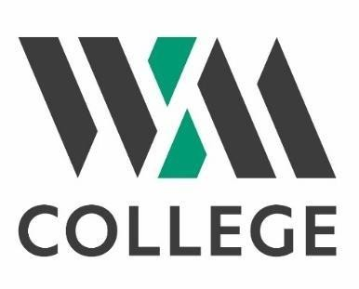

College Rooms and Space Hire - 2023

WM College offers a variety of high specification spaces available for hire in its beautiful grade 2 listed building in Crowndale Road, Camden. These rooms are suitable for exhibitions, classes, training and meetings.

Location:
WM College is ideally situated within a 3 minute walk from Mornington Crescent tube station and a 10 - 15 minute walk from Kings Cross / St Pancras, Euston or Camden Town stations. More than 10 bus routes run locally to the College.

Facilities Include:
- Wi-Fi throughout the building
- Tables and chairs with flexible layouts
- Smart boards
- Café
- WCs including accessible facilities
- Bike parking space

Room layouts available:
- Theatre style
- Classroom style
- Boardroom style
- Conference style
- U-Shaped with tables
- U-Shaped without tables

Refreshment Options:
Hirers may make use of the in-College café to purchase a range of hot and cold food, drinks and snacks or arrange with the café in advance for refreshments to be provided (at additional cost) in the meeting venue. A range of menu options is available to suit your needs and any special dietary requirements.

Capacity and usage:
Small classrooms can seat up to 16 people. Ideal for training, teaching, meetings and conferences.
Large classrooms can seat up to 22 people. Ideal for training, teaching, meetings and conferences.
Large Hall has a capacity of 80 people. Our Maurice Hall is a great multipurpose room that can be used for exhibitions, training, activities, lectures and so much more.
Our Small meeting room is great for interviews, small meetings, blended meetings (online and onsite). Our Small meeting room can seat up to 6 people.
Large Meeting / Boardroom has Grade 2 listed features and holds up to 16 people in meeting or Boardroom style

Hiring Costs (Term time) - Rate per hour

 | Monday – Friday 9:00 - 17:00 | Monday –  Thursday 17:00 - 21:00 | Saturday 9:00 - 15:30
Small Classroom | £25 | £35 | £40
Large Classroom | £35 | £45 | £50
Large Hall | Please enquire for prices and availability
Small Meeting Room | £25 | £30 | £35
Large Meeting / Boardroom | £45 | £55 | £60

Hiring Costs (Non-Term time)

 | Monday - Friday 9:00 - 17:00 | Monday - Friday 17:00 - 21:00 | Saturday 9:00 - 15:30
Small Classroom | Please enquire for prices and availability*
Large Classroom
Large Hall
Small Meeting Room

Please check the College website (www.wmcollege.ac.uk) for term dates.

*The College buildings are not usually open in the evenings or Saturdays outside term time, so the hire rate would need to reflect the full additional cost of staff to open and operate the building for your event.

If you would like to make a booking for room hire, please complete and return the booking enquiry form to andyc@wmcollege.ac.uk
If you have any questions or would like additional information about the facilities, please contact Andy Christophi on andyc@wmcollege.ac.uk

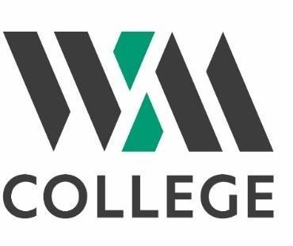
Booking Enquiry Form

Please complete this form in BLOCK LETTERS. Once we have received your form, we will check availability and inform you if the space you have requested is available. If you have any queries or would like to visit us to see the options available, please contact Andy Christophi at andyc@wmcollege.ac.uk

Name:
Name of Organisation (if applicable):
Address:
Telephone:
E-mail:
Contact details of person who will be responsible on site during the booking hours:

Name:
Address:
Mobile telephone:
E-mail

Date/s of proposed booking:
Time of booking:
Purpose of the booking:
Room layout:
Estimated number of people attending:
Additional equipment required:
Room requested (if known):
Any Specific Requirements:
Please note that your booking is provisional until we have sent you confirmation of booking by email. We will be conducting a number of checks as to the suitability of the hiring individual / organisation, prior to final booking confirmation.
Please return completed form to: andyc@wmcollege.ac.uk

